Using the Chronolator Samples
A practical guide to the main features of Chronolator
Version 3.3

Chronolator © 2004 - 2014 Berrick Computing Ltd
www.chronolator.co.uk

Microsoft Word © Microsoft Corporation
Contents
1 Introduction 6
1.1 What is Chronolator and what does it do? 6
1.1.1 Administrators 6
1.1.2 Front-line staff 6
1.1.3 Reviewers 6
1.1.4 The Chronolator Process 7
1.2 About this document 10
1.3 Chronolator Documentation 10
1.4 A note about Word versions and options 10
1.4.1 Limited support for Word 2000 10
1.4.2 Word for Apple Mac 10
1.4.3 How can I tell which version of Word I am using? 11
1.5 Viewing and printing this document 12
1.5.1 Conventions and Symbols 12
1.5.2 Online viewing 12
1.5.3 Printing 14
2 About the Sample Documents 15
3 The Chronolator Toolbar 16
3.1 Macros 16
3.2 Accepting the Licence 16
4 Exercises 17
4.1 About the Exercises 17
Exercise 1 - Entering, formatting, and sorting events in an Internal Chronology 19
Exercise 2 - Error Checking 24
Exercise 3 - The Age and Interval Calculator 29
Exercise 4 - Importing and Merging tables into a Composite Chronology 32
Exercise 5 - Finding duplicated events 40
Exercise 6 - Giving events a Reference Number 44
Exercise 7 - Forcing events into order 47
Exercise 8 - Highlighting events according to their agency or organisation 52
Exercise 9 - Anonymising and Personalising a chronology 58
Exercise 10 - Updating the Abbreviations Glossary 63
Exercise 11 - Navigating a document and extracting events using the Abbreviations Glossary 67
Exercise 12 - Making a narrative version of the chronology table 73
5 Conclusion 80

Figures
Figure 1 - multiple levels of administration - schematic document flow 8
Figure 2 - multiple levels of administration - a possible scenario 9

Introduction

What is Chronolator and what does it do?
Chronolator makes it easy to produce the chronologies that are needed to review interactions between different agencies and organisations. Since it is based on Microsoft Word, little specialist knowledge is required to use it. There are no new programs to learn or install, and only a basic knowledge of working with Word tables is required.
Chronolator has something to help everyone involved in using a chronology to investigate a case:
- those who supervise and administer it;
- the front-line staff who input the data;
- those who review it.

Administrators
Gathering and collating chronologies from multiple agencies is a time consuming task, particularly if they each have different ideas about what they need to provide. Chronolator enforces the standards set by the administrator (for example, what column headings the chronology table should have) and automates the merging of individual chronologies.

Front-line staff
Transcribing written records from various sources into a consistent format is a tedious and error-prone task. Chronolator simplifies the process with a number of tools. There are tools to sort records into order, to put dates into consistent formats, and to check for a variety of problems.

Reviewers
The final objective of a chronology is that someone can make sense of the events it contains. Chronologies are often anonymised, which can make it difficult to build a mental picture of the people involved. The Chronolator anonymisation tool lets you switch back and forth between anonymised and personalised views of a document.
Other tools for reviewers include:
- reports about individuals identified in the Abbreviations Glossary;
- colour-coding events according to the agency reporting them;
- a calculator to work out the interval between two dates;
- formatting a tabular chronology into a narrative layout.

The Chronolator Process
The Chronolator process begins when the Case Review Administrator sets up an Internal Chronology, which is a Word document containing a table whose headings and other characteristics are specified by the Administrator.
The Case Review Administrator distributes the Internal Chronology to the various organisations whose data is required.
If an organisation needs to collect data from several departments, the recipient can forward the Internal Chronology to them and ask them to complete it rather than calling for their original records. Anyone forwarding a document in this way is called a Local Administrator.
When the holders of the original records have completed their documents, they return them to the Administrator who wanted the information (either the Case Review Administrator or a Local Administrator). That Administrator uses Chronolator to merge them into a Composite Chronology.
There is no limit to the number of levels of Local Administration.
The diagrams below (Figure 1 on page 8 and in Figure 2 on page 9) illustrate the flow of documents between administrators and data collectors.
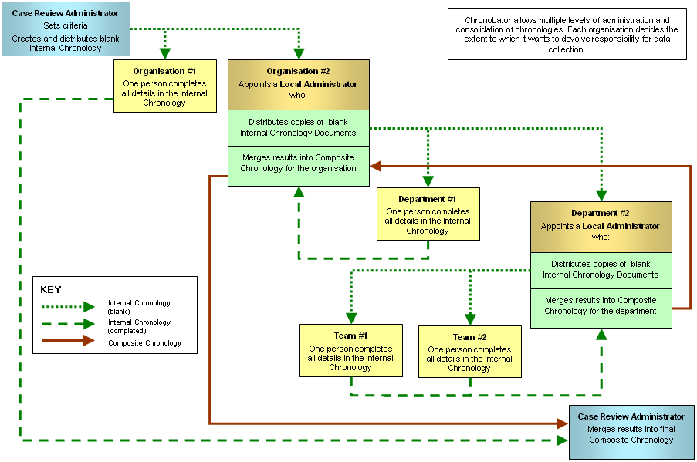
Figure 1 - multiple levels of administration - schematic document flow
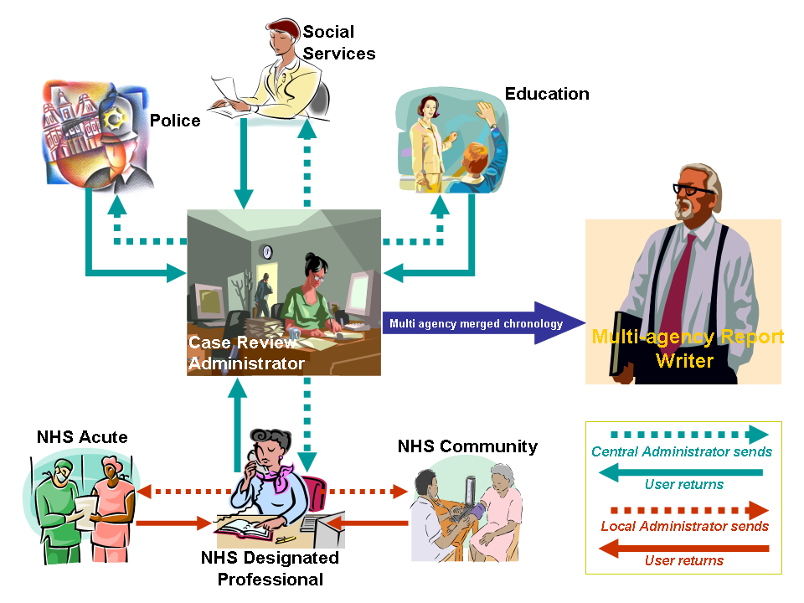
Figure 2 - multiple levels of administration - a possible scenario

About this document
This document contains a number of exercises using the Chronolator sample documents. Each exercise can be done on its own and should only take a few minutes to complete.

Chronolator Documentation
Setting Up Chronolator Documents describes how to create Chronolator Documents using the Chronolator Online Workbench, and how to distribute them.
Using Chronolator Documents describes how Chronolator facilitates the production of accurate chronologies, how to combine Chronolator Documents into Composite Chronologies, and the other tools and features Chronolator provides.
Using Chronolator Samples (this document) contains some exercises you can undertake with the sample documents to acquaint yourself with the main features of Chronolator.
For information about the terminology used in this document (e.g. ‘Internal Chronology’, ‘Local Administrator’), see Appendix E - Chronolator Terminology in the Using Chronolator Documents manual.
These documents can be downloaded from www.chronolator.co.uk/documentation.

A note about Word versions and options
The illustrations in this document were mostly taken using Word 2013 with a typical set of user options; your own experience might be slightly different. Separate instructions are provided for each Word version if there are marked differences.
Chronolator documents are supplied in the docm format introduced with Word 2007. They can be opened in Word XP and 2003 if the Microsoft Office Compatibility Pack is installed. They can be saved in the old doc format if need be.

Limited support for Word 2000
Word 2000 is no longer supported by Microsoft. Macros in docm files are not supported in Word 2000 even if the Compatibility Pack is installed. Word 2000 is therefore not suitable if you want to use the Chronolator Online Workbench.
If you are using Word 2000 and your administrator has sent you an Internal Chronology as a docm file, ask them to save and send you a doc version.

Word for Apple Mac
Chronolator is designed for and tested on Windows versions of Word. It will certainly not work with Word 2008 for Mac, as it does not include the Visual Basic for Applications programming environment used to run macros. It might run OK on other versions of Word for Mac, but it is not tested on them and support is not guaranteed.

How can I tell which version of Word I am using?
The simplest way is to look at the 'splash screen' Word displays while it starts.
Word XP | Word 2003 | Word 2007 | Word 2010 | Word 2013
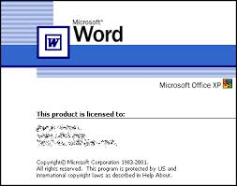 | 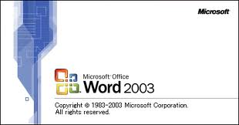 | 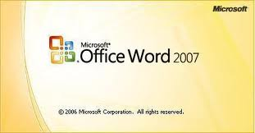 | 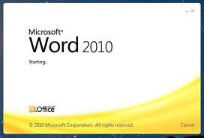 | 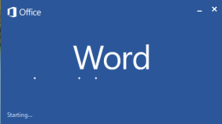

Alternatively, type 'how can I tell which version of Word I am using' into a search engine. At the time of writing, the most useful link this revealed was on Microsoft's web site:
http://office.microsoft.com/en-gb/word-help/what-version-of-office-am-i-using-HA101873769.aspx.

Viewing and printing this document

Conventions and Symbols
Text like this generally denotes something on the screen that you can press.
Text like this denotes a reference to a tool or function, or is used for general emphasis.
Text like this refers to a document.
Hyperlinks to other places in the document, or to other documents, are displayed like this.
This symbol marks a hint or tip.
This one marks a Warning.

Online viewing
This document is available in Word and PDF versions.
We recommend the Word version for online reading. Use the Web Layout and Navigation Pane options on the View tab to avoid unnecessary page and table breaks and give you an overview of the document headings. Clicking on one of the headings in the Navigation Pane takes you to the relevant part of the document.
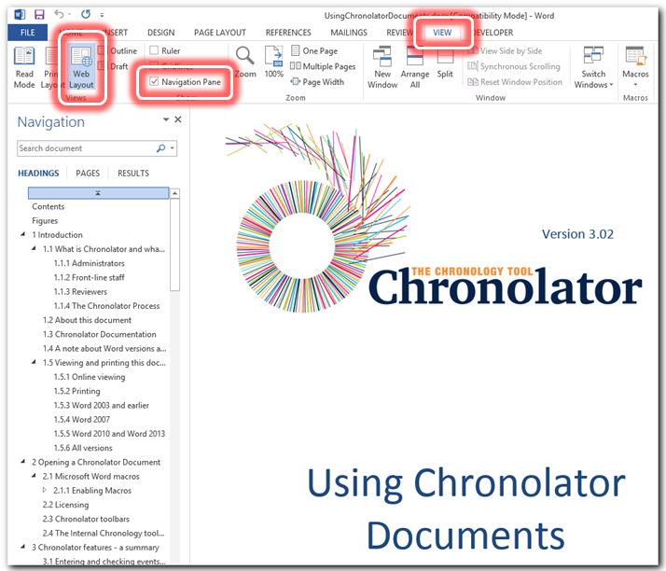

Hyperlinks
The document also contains hyperlinks, which are displayed like this. Click on one to go to the relevant part of the document.
We recommend that you add the Back button to the Quick Access Toolbar (QAT) on the ribbon so that you can go back to where you came from. Follow the instructions below to see how to do this.
Press the small arrow to the right of the QAT, and click on More Commands . . . | 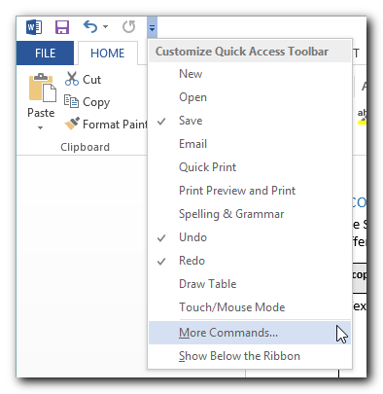
Under Choose Commands From , select Commands Not in the Ribbon.  Scroll down to Back.  Press Add >>.  Press OK. | 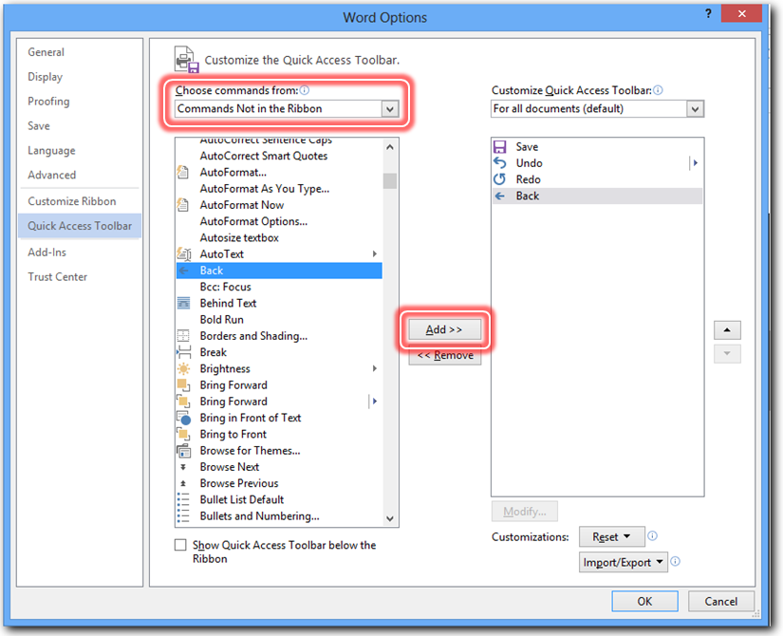
The Back button is added to the QAT: | 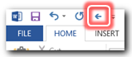

Now, after you have followed a hyperlink, you can use the button to go back to where it occurred.

Printing
For printing we recommend the PDF version of this document as it avoids any issues with page numbering.
If you nevertheless want to print the Word version, note that Word resolves page references ‘on the fly’. To make sure they are correct when you print it, ensure that the relevant Word option is turned on as described below.

Word 2003 and earlier
Press Tools > Options > Print and tick the Update Fields box.

Word 2007
Press > > Word Options > Display and tick the Update fields before printing box.

Word 2010 and Word 2013
Press File > Options > Display and tick the Update fields before printing box.

All versions
If you get a message like this, select Update Entire table and press OK. | 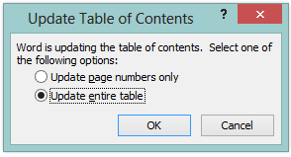

About the Sample Documents
The sample documents can be used to practise using Chronolator and to familiarise yourself with its main features. They include an Internal Chronology containing a number of errors and some error-free Internal and Composite Chronologies. Each one is briefly described in the table below.
You can open each sample and experiment, or if you prefer to take a more structured approach you can follow some of the exercises later on in this document.
If you save any changes you make but want to go back to the original versions, you can always download them again from www.chronolator.co.uk/download.htm.
Sample | Description
SampleTableWithErrors | An Internal Chronology containing examples of most of the problems Chronolator looks for in a chronology, such as missing entries.
SampleInternalChronologyPolice | An error-free Internal Chronology.
SampleInternalChronologySocialCare | An error-free Internal Chronology.
SampleInternalChronologyBerrickshireAmbulance | An error-free Internal Chronology.
SampleCompositeChronologyHealth | An anonymised error-free Composite Chronology such as might have been assembled by the Designated Professional in Figure 2 on page 9.

The Chronolator Toolbar
Chronolator makes its various features available on a new Word Toolbar. In order for it to do so, you must ensure that macros can run and accept the terms of a licence.

Macros
When you open a Chronolator document, Word will probably inform you that it contains macros and ask you whether you want them to run. You should allow them to.
If you do not know how to enable macros, please refer to the information about them in Using Chronolator Documents before embarking on these exercises.

Accepting the Licence
After you have allowed macros to run, Chronolator will ask you to accept the terms of its Evaluation Licence (this is true even if you have purchased a full licence).  You only need to accept the licence terms in the first sample document you open in a Word session.  Press OK to accept the licence terms. | 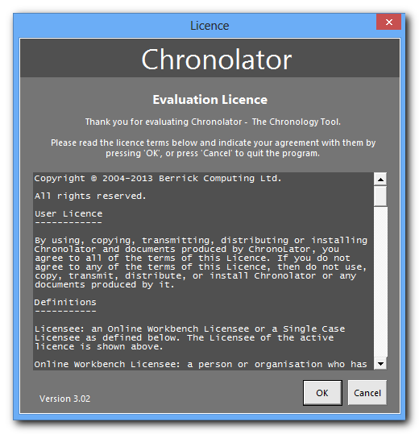
The Chronolator toolbar will appear:
In Word 2007 and later versions, the Chronolator toolbar is added to any other custom toolbars on the Ribbon’s Add-Ins tab. | 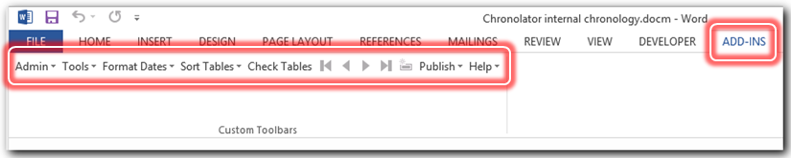
In Word 2003 and earlier versions, the Chronolator toolbar is added below your other toolbars. | 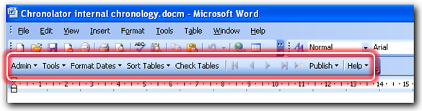

The exercises in this document use most of the tools provided on the Chronolator toolbar. For more information, refer to the Using Chronolator Documents manual.

Exercises

About the Exercises
The exercises in the following sections will help you become familiar with Chronolator’s main features. Choose which ones you want to do - there is no need to do them all in order.
All the exercises assume that the sample documents have not been changed. If that is not the case, you can download them again from www.chronolator.co.uk/download.htm.
Don’t forget to enable macros after opening each document if you are prompted to do so.
Chronolator often displays a completion message of some kind after it has done a bit of processing. Also, some tools stay open so you can use them repeatedly while checking results in the background. Unless it is important for the exercise, the instructions below do not mention these things: just press OK, Close, or whatever you need to dismiss the message or tool and carry on.
Sometimes, while processing or before you dismiss a message or tool, parts of the chronology table might look broken, a bit like the first rows in this table:  This is due to a bug in Word which we have so far been unable to circumvent.  There is no need to worry; when processing completes and you dismiss any messages, the table will be correctly displayed. | 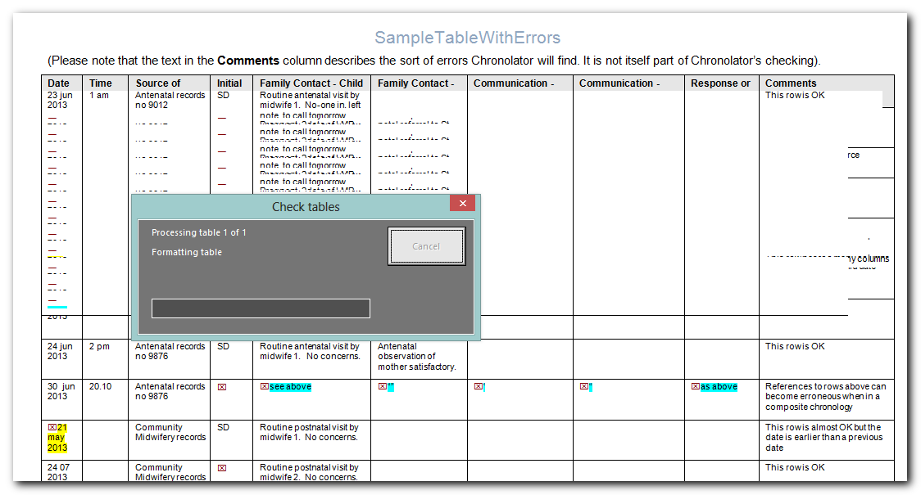
If you are using Word's Auto-save feature, a red box will be added to the document header at every auto-save interval. You can safely ignore it. | 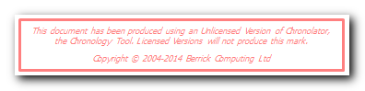

Many of the exercises have equivalent video demonstrations at www.chronolator.co.uk/tutorials. You might like to watch the demonstration before undertaking an exercise.

Exercise 1 - Entering, formatting, and sorting events in an Internal Chronology
Chronolator has a number of features to help you quickly transcribe events from other sources and produce a high quality chronology which meets the requirements of the Case Review Administrator.
Step | Action | What to expect and other comments
 | Read The Chronolator Toolbar on page 16, and About the Exercises on page 17 if you have not already done so.
 | Open SampleInternalChronologyPolice.
 | Click in the bottom right hand cell of the table.
 | Press the Tab key on the left of your keyboard:  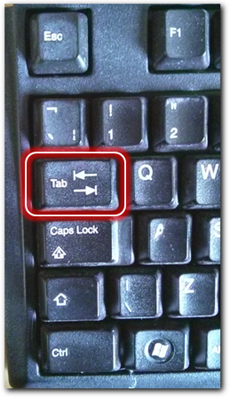 | A new row is added to the table.  You can add events to the bottom of the table as new records come to hand. There is no need to hunt around in the table looking for where they should go - you can use Chronolator to put them in the right order.
 | Type 16feb13 in the Date Column.  Type 1pm in the Time column.  Type My first new event in the Comments column. | The dates and times are exactly as you might have found them in some paper records. Being able to do this lessens the possibility of errors in transcription.
 | Press the Tab key to add a new row to the table.
 | Type 22/5/12 in the Date Column.  Type 2.30 in the Time column.  Type Another new event in the Communication - within agency column. | The bottom two rows should now look like this:  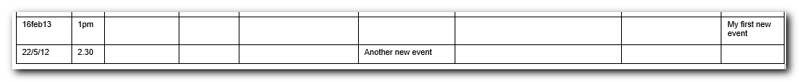
 | Press Format Dates on the Chronolator toolbar and press the first option from the list that drops down: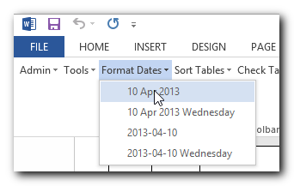 | The dates and times are put into the specified format:  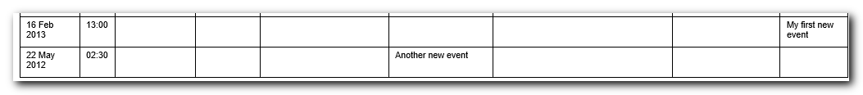  Format Dates formats times as well.
 | Press Sort Tables on the Chronolator toolbar and press Ascending:  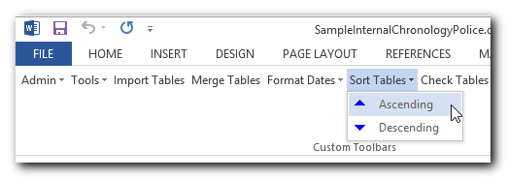 | The events that you added are put in the right places in the table:  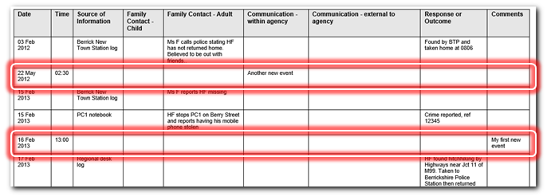
 | Close SampleInternalChronologyPolice without saving changes. | Chronolator checks the document for errors.  Internal Chronologies are checked every time they are closed, helping to ensure that administrators receive error-free documents.  When the check completes, Message 3005 is displayed, asking you to correct the errors before returning the document:  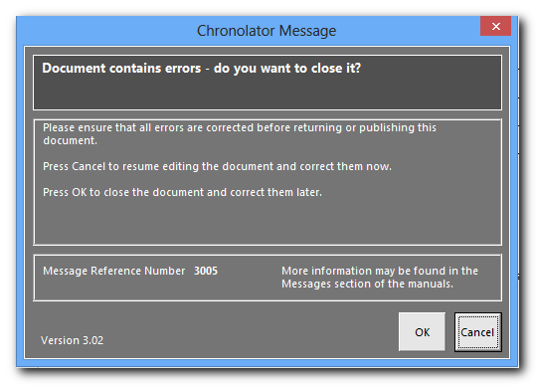  One of the checks that Chronolator makes is that certain columns must always be completed. This exercise deliberately did not ask you to type anything in the mandatory Source of Information column so you could see what happens when you close a document containing errors.
 | Press OK as if you want to correct the errors later. | The document closes.  You would press Cancel if you wanted to keep the document open and correct the errors.

In this exercise, you have learnt that:
- you can add new events at the bottom of the chronology table and let Chronolator put them in order;
- you can enter dates and times exactly as written on the source records and let Chronolator put them in a consistent format;
- Chronolator checks an Internal Chronology for errors every time it is closed.

Exercise 2 - Error Checking on page 24 has more information about the sort of errors Chronolator detects, how you can find out more about them, and how you can check for them whenever you want.

Exercise 2 - Error Checking
Chronolator automatically checks for errors every time an Internal Chronology is closed. It does not save the details about any errors it finds unless you save the document, so you can also check for them at any time by pressing the Check Tables button on the toolbar.
Step | Action | What to expect and other comments
 | Read The Chronolator Toolbar on page 16, and About the Exercises on page 17 if you have not already done so.
 | Open SampleTableWithErrors.
 | Close SampleTableWithErrors. | Chronolator checks the document for errors. When the check completes, Message 3005 is displayed, asking you to correct the errors before returning the document:  Internal Chronologies are checked every time they are closed, helping to ensure that administrators receive error-free documents.
 | Press OK. | The document closes.  You would press Cancel if you wanted to keep the document open and correct the errors.
 | Open SampleTableWithErrors.
 | Press Check Tables on the Chronolator toolbar:  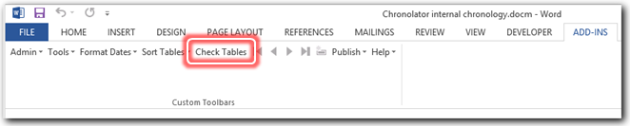 | Chronolator checks the document for errors.  When the check completes, Message 3000 is displayed:  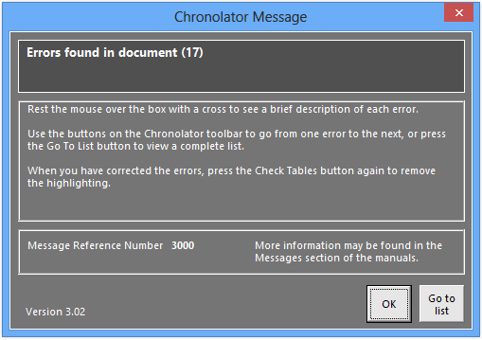  Chronolator has been designed so that there is little need to read the extensive documentation unless you are the sort of person who likes to. The messages it displays usually have enough information in them for you to know what to do next.
 | Press OK. | Message 3001 is displayed:  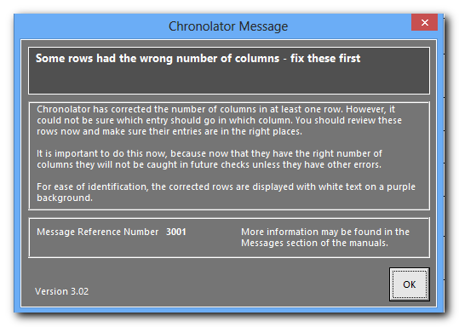  Chronolator can correct rows which have the wrong number of columns, but it cannot be sure that it has placed information under the correct heading.
 | Press OK. | The document is displayed with errors highlighted. A flag like this is shown to the left of each error:  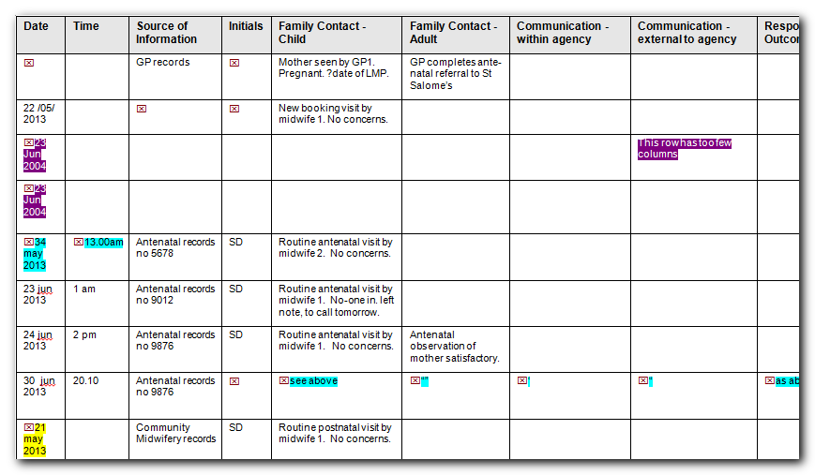
 | Use the navigation buttons on the toolbar to go from one error to the next:  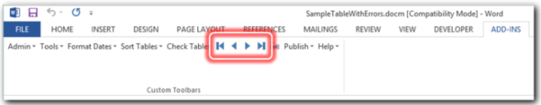 | The cursor goes to the requested error.  In this short sample document there is not much advantage in doing this over simply looking for highlights, but if there are just a few errors in a 300-page document, the navigation buttons become very useful.
 | Press the Go To List navigation button:  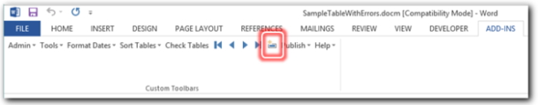 | The document scrolls to the list of errors at the bottom:  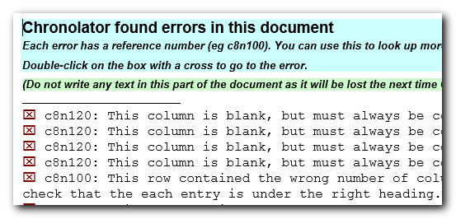  The error list is a useful way to get an idea of what sort of errors are in the document.
 | Double-click on one of the flags to the left of an error description. | The document scrolls and the cursor is placed next to the error.
 | Rest your mouse on one of the flags to the left of an error. | A description of the error pops up:  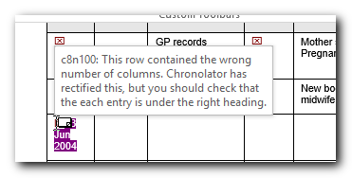
 | Correct some of the errors - for example, by adding some text to the blank cells, or correcting the invalid date.  You do not need to delete the flag, but it does not matter if you do. | The highlighting remains even when you have corrected an error.  Chronolator does not check for errors as you type - this would make it very slow You need to check the tables again to remove highlights from corrected errors.
 | Press Check Tables on the Chronolator toolbar. | A message is issued saying whether or not any errors were found.
 | Press OK. | Highlighting is removed from the errors you corrected. Any other errors are highlighted.
 | Close SampleTableWithErrors without saving changes. | Chronolator checks the document for errors.  A message is issued saying whether or not any errors were found.
 | Press OK. | The document closes.

In this exercise, you have:
- seen that Chronolator checks an Internal Chronology for errors whenever it is closed;
- used the Check Tables button to check for errors on demand;
- seen examples of the errors Chronolator looks for;
- learned that Chronolator does not check for errors as you type, so you must press Check Tables after correcting them to remove any highlighting;
- used the error navigation buttons to go from one error to another, or to a complete list of errors;
- clicked on the symbols in the error list to go to where an error is in the document.

Exercise 3 - The Age and Interval Calculator
When you are working on a chronology, it is often useful to know the interval between two dates. The Age and Interval Calculator does just that, and lets you copy and paste its results into your document.
Step | Action | What to expect and other comments
 | Read The Chronolator Toolbar on page 16, and About the Exercises on page 17 if you have not already done so.
 | Open SampleCompositeChronologyHealth.
 | Press Tools > Age Calculator on the Chronolator toolbar:  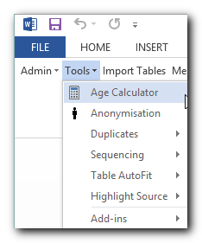 | 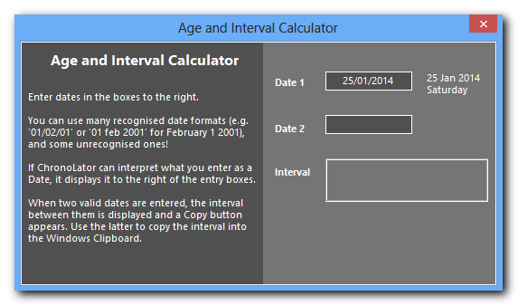  The Age and Interval Calculator opens:  The calculator works out the difference between Date 1 and Date 2.  If you have not used it before in this document, Date 1 has today’s date in it, and Date 2 is blank.  If you have used it before and saved the document, the last two dates you used will be shown.
 | Type 1 2 into the Date 2 box. | 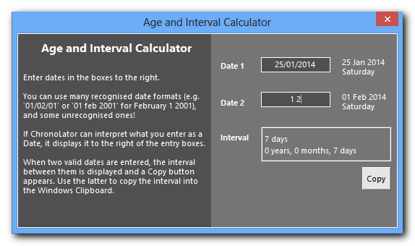  Notice that as soon as Chronolator can interpret what you type as a date, it tells you its interpretation to the right of the box and a Copy button appears. In the example here, Chronolator has interpreted '1 2' as the first of February in the current year.
 | Carry on typing, so the box now says 1 2 3. | 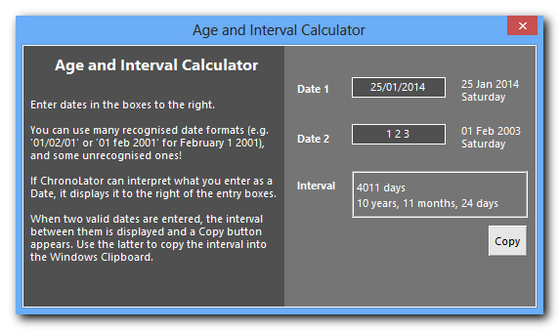  Chronolator has interpreted '1 2 3' as the first of February in the year 2003.
 | Press Copy. | The text in the Interval box is copied to the clipboard.
 | Click somewhere in the document. | You do not need to close the Calculator.
 | Paste the clipboard in your usual way: e.g. by pressing Ctrl + V, or by pressing Paste on the Home tab:  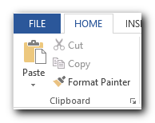 | The text is pasted into the document at the position you chose:  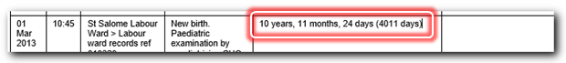  It is now just like any other document text and you can edit it as you please - perhaps to change the full detail 10 years, 11 months, 24 days (4011 days) to something shorter like 10 years 11 months.
 | Experiment with other date formats such as 22.05.52 and Dec 25 50. | 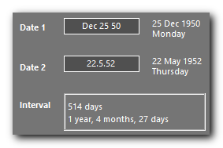  Chronolator accepts a variety of date formats, just as it does when you enter a date in a chronology.
 | Close SampleCompositeChronologyHealth without saving changes.

In this exercise, you have learnt that:
- the Age and Interval Calculator can be used to work out the time passed between two dates;
- it accepts dates in many formats, some quite unconventional;
- you can copy and paste the calculator results into your document.

Exercise 4 - Importing and Merging tables into a Composite Chronology
The main reason Chronolator was written was to simplify and accelerate the process of collating chronologies from many sources into a multi-agency Composite Chronology.
Anybody can do this, not just a Chronolator licensee: every Internal Chronology includes a New Composite Chronology button to start the process.
Step | Action | What to expect and other comments
 | Read The Chronolator Toolbar on page 16, and About the Exercises on page 17 if you have not already done so.
 | Open SampleInternalChronologyPolice. | This will be the first document we import into the new Composite Chronology. The first few rows look like this:  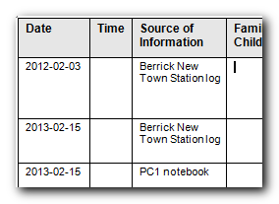  Notice that the Police have completed the Source of Information column with information about their own records: they have mentioned nothing about being the Police.
 | Press Admin > New Composite Chronology on the Chronolator toolbar:  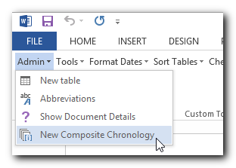  When they come to do this on a real case, licensees should use the New Composite Chronology button on the Online Workbench toolbar, as the document will usually be licensed for longer. | Word’s Save As dialog is displayed:  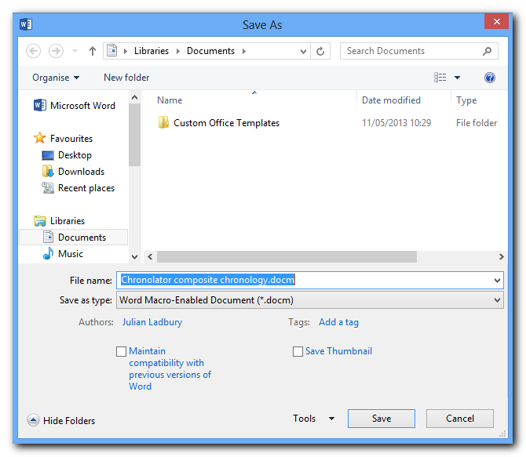
 | Save the new Composite Chronology wherever you like (e.g. in My Documents), giving it a name of your choice. In this exercise, we will use the Chronolator suggestion of Chronolator composite chronology. | SampleInternalChronologyPolice closes, being replaced by Chronolator composite chronology.  The toolbar changes to include just Import Tables and Help buttons.
 | Press Import Tables on the Chronolator toolbar:  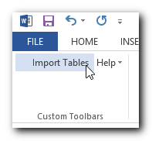 | Word’s Open dialog is displayed.
 | Find and open SampleInternalChronologyPolice:  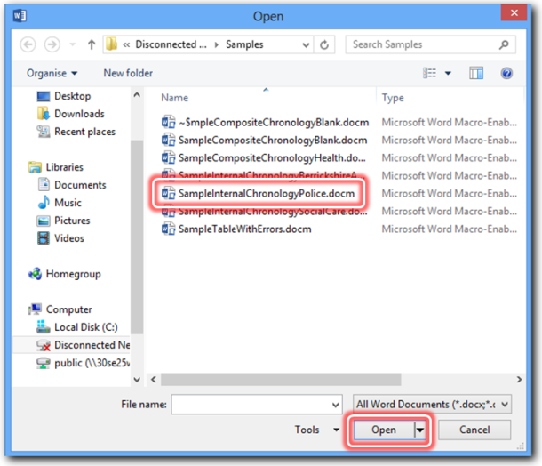 | The Source of Information dialog appears:  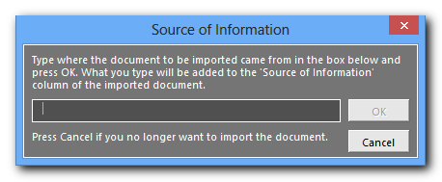
 | Type Police in the box and press OK:  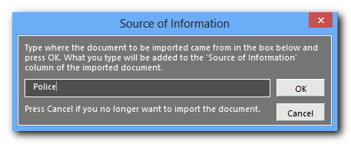  What you type in the box will be added to the beginning of the Source of Information column. | Message 1000 is displayed:  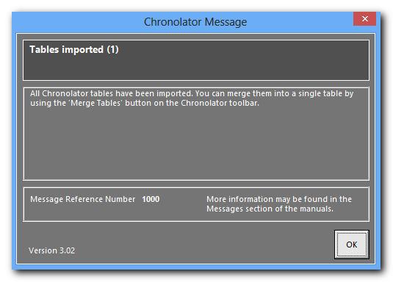
 | Press OK. | The Police document has been imported. Its Source of Information column has been updated:  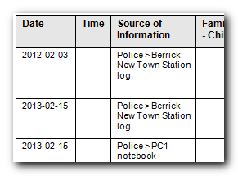  Also, more buttons have been added to the Chronolator toolbar, and the Import Tables button has moved along a bit:  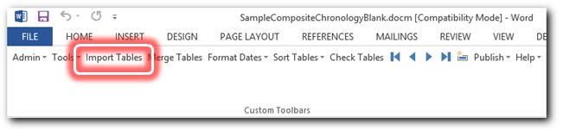
 | Press Import Tables on the Chronolator toolbar. | Word’s Open dialog is displayed.
 | Find and open SampleInternalChronologySocialCare. | The Source of Information dialog appears.
 | Type Social Care in the box and press OK. | The Social Care table is copied to the bottom of the document, and its Source of Information column has been updated.  The table is added to the Composite Chronology as a new table; it is not merged with what is already there.
 | Press Import Tables on the Chronolator toolbar. | Word’s Open dialog is displayed.
 | Find and open SampleCompositeChronologyHealth. | The Source of Information dialog appears.
 | Type Health in the box and press OK. | The Health table is copied to the bottom of the document, and its Source of Information column has been updated.
 | Review the contents of the Composite Chronology. | There are three separate tables. Import Tables does just that and nothing else.  Each table has different column widths and date formats. Merging these by hand into a single table with events consistently formatted and in the right order would take some time.
 | Save Chronolator composite chronology using standard Word Save. | It is always good practice to save your work from time to time so that you can pick up where you left off if something goes wrong.
 | Press Merge Tables on the Chronolator toolbar. | Message 1100 is displayed:  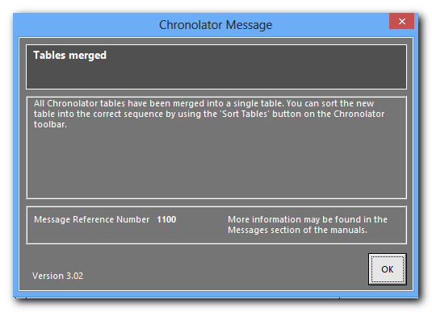
 | Press OK. | The tables have been merged into a single table with uniform column widths.  Events are still in the same order they were imported - Police, Social Care, Health. Merge Tables does just that and nothing else.
 | Press Format Dates on the Chronolator toolbar and choose an option from the list that drops down:  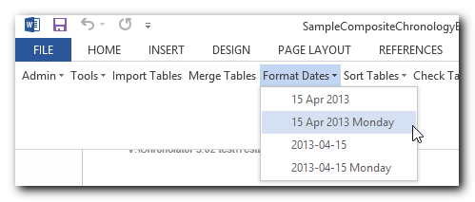 | The dates and times are put into the format you choose.
 | Press Sort Tables > Ascending on the Chronolator toolbar:  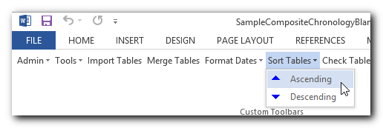 | The events are put in date and time order.  On any one day, events with blank times are put before those whose time is specified
 | Press Check Tables on the Chronolator toolbar: | No errors are found.  Having imported, merged, and sorted three error-free documents, there is no reason to expect any - but it is always sensible to check.
 | Close Chronolator composite chronology, saving changes or not as you wish.

In this exercise, you have learned that:
- assembling a Composite Chronology involves Importing, Merging, Formatting, and Sorting tables. Note that the exercise did NOT illustrate that if you have many chronologies to merge, it is up to you whether you import them all first and then do the other tasks, or do each one as you go, or some other combination;
- Chronolator will format all dates and times for you consistently;
- Chronolator will put events into the correct order.

Sometimes, when the times of some events are known while those of others are not, you might want to force events into a certain order. Exercise 7 - Forcing events into order on page 47 illustrates how to do that.

Exercise 5 - Finding duplicated events
Suppose you have already put together a Composite Chronology. One of the agencies in it sends you an updated version of their chronology with some new events, but they are unable to tell you exactly what they have changed. To save you having to trawl through the two chronologies to identify what updates need to be made, simply import and merge the new version and use the Duplicates tool to highlight or delete the events you already had.
In this exercise we will highlight duplicates first, then delete them. There is no need to do this though - you can delete them without highlighting them if you want.
Step | Action | What to expect and other comments
 | Read The Chronolator Toolbar on page 16, and About the Exercises on page 17 if you have not already done so.
 | None of the Sample documents contains any duplicated rows. We shall make some in the first steps of this exercise, which have a light blue background . . .
 | Open  SampleInternalChronologyBerrickshireAmbulance. | 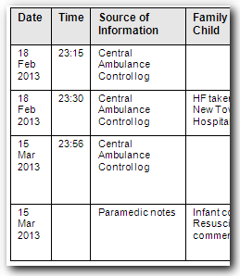  Note that this chronology has four events from Berrickshire Ambulance Service: two on 18 Feb 2013 and two on 15 Mar 2013.
 | Close  SampleInternalChronologyBerrickshireAmbulance. | The only reason to open it was to look at the events.
 | Open SampleCompositeChronologyHealth. | This chronology already contains the two events on 15 Mar 2013 from Berrickshire Ambulance Service.
 | Import  SampleInternalChronologyBerrickshireAmbulance,  giving it the Source of Information Berrickshire Ambulance Service.  Press Merge Tables on the Chronolator toolbar.  Press Sort Tables > Ascending on the Chronolator toolbar. | For an exercise about Import and Merge, see Exercise 4 - Importing and Merging tables into a Composite Chronology on page 32.
 |  | . . . we have now ensured that the Composite Chronology contains duplicated rows from the Ambulance Service.
 | Press Tools > Duplicates > Highlight on the Chronolator toolbar:  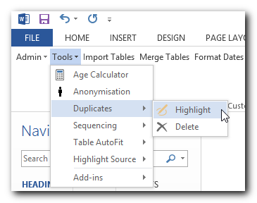 | The Duplicate Rows form is displayed:  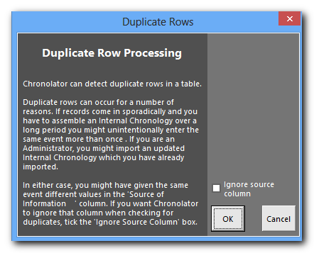
 | Press OK. | Message 3025 is displayed, saying that two duplicate rows have been found:  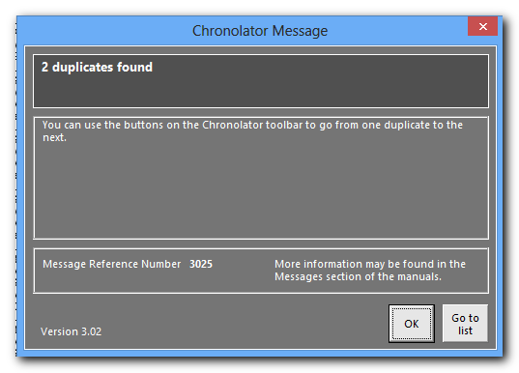  If not, you might have mistyped the Source of Information in step 6. Try repeating Step 8, having ticked the Ignore source column check box.  Refer to Using Chronolator Documents for more details.
 | Press OK.
 | Press the leftmost navigation button on the toolbar:  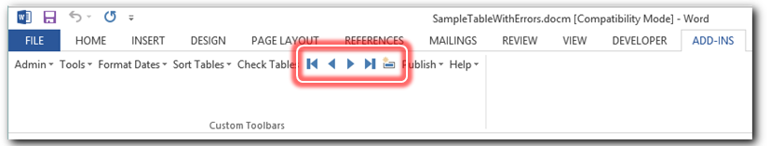 | The document scrolls to the first duplicate, which is highlighted in pale blue:  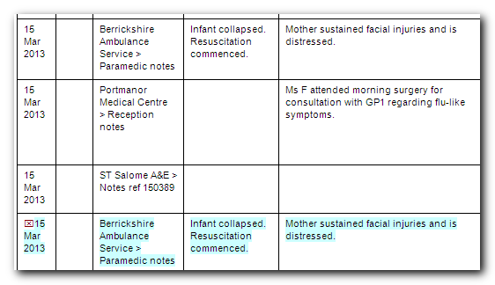  The original event is not highlighted; it is 3 rows before the duplicate.
 | Press Tools > Duplicates > Delete on the Chronolator toolbar:  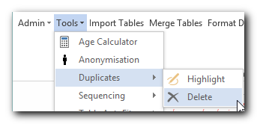 | The Duplicate Rows form is displayed:  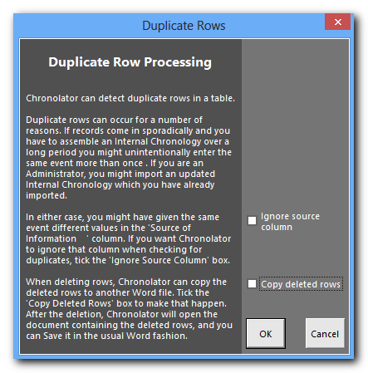  Refer to Using Chronolator Documents if you are interested in the Copy deleted rows check box. It saves the deleted rows in a new document, but is not used in this exercise.
 | Press OK. | The two duplicate rows have been deleted, and Message 3030 is issued to confirm this. Press OK to dismiss it.
 | Close SampleCompositeChronologyHealth without saving changes.

In this exercise, you have seen that:
- Chronolator can detect duplicate rows in a document. These can occur if you import an updated version of a chronology into a Composite Chronology, or if you enter the same event more than once, perhaps when resuming work after a holiday.
- having detected duplicate rows, Chronolator can highlight or delete them for you.

Exercise 6 - Giving events a Reference Number
You might like to give each event a Reference Number. Chronolator’s Sequence column lets you do that.
Step | Action | What to expect and other comments
 | Read The Chronolator Toolbar on page 16, and About the Exercises on page 17 if you have not already done so.
 | Open SampleCompositeChronologyHealth.
 | Press Tools > Sequencing > Add Column on the Chronolator toolbar:  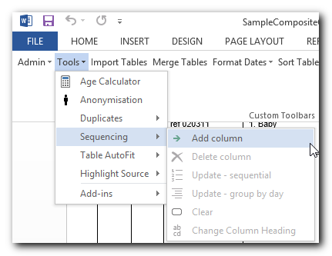 | A column is added at the left of the table. Its heading is Seq:  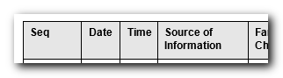  An Administrator can define a Sequencing column when setting up the document, or - as in this exercise - it can be added later.  You can change the column heading, unless it was defined by the Administrator in an Internal Chronology, which is not the case in this exercise. You do this later in this exercise.  If the table overflows the page margins, or a heading wraps inappropriately, you can use one of the the Tools > Table AutoFit options to fix it.
 | Press Tools > Sequencing > Update - sequential:  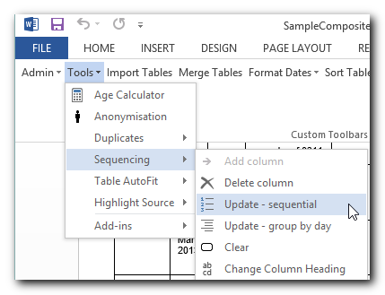 | The Seq column is updated with reference numbers, starting at 1 and increasing by 1:  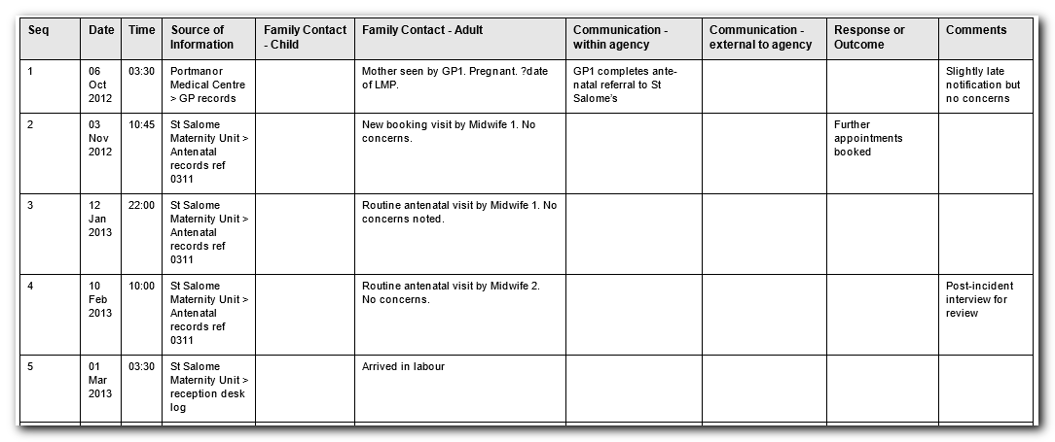  If you want numbering to restart at 1 on each new day, press Tools > Sequencing > Update - group by day
 | Press Tools > Sequencing > Change Column Heading:  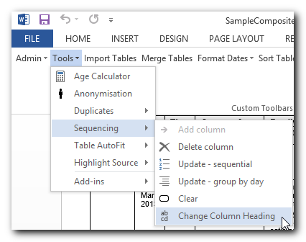 | A form is displayed in which you can specify the new heading:  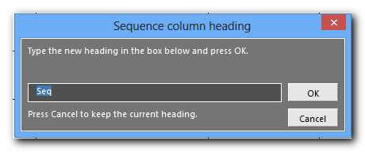
 | Type the new heading - let’s call it Reference - and press OK:  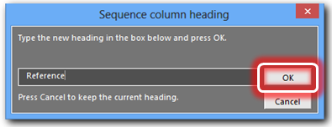 | The heading is changed:  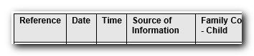  If the table overflows the page margins, or a heading wraps inappropriately, you can use one of the the Tools > Table AutoFit options to fix it.
 | Close SampleCompositeChronologyHealth without saving changes.

In this exercise, you have seen that:
- you can use a Sequence column to add reference numbers to events. The numbers can increase throughout the document, or start at 1 on each new day;
- you can add a Sequence column to a table which does not have one. This is the only change that Chronolator allows you to make to the column headings defined by the Case Review Administrator.
Exercise 7 - Forcing events into order on page 47 illustrates how you can use a Sequence column to force events into order when there is insufficient information about the time on which they occurred.

Exercise 7 - Forcing events into order
Sometimes you might not know at what time events happened on a particular day, but you do know their order. Chronolator’s Sequence column lets you specify that order.
Step | Action |  |  | What to expect and other comments
 | Read The Chronolator Toolbar on page 16, and About the Exercises on page 17 if you have not already done so.
 |  | Open SampleCompositeChronologyHealth.
 |  |  | Look at the events of March 15. They are obviously in the wrong order - for example, in the first one the baby has collapsed, while in the second one, the baby was well. | 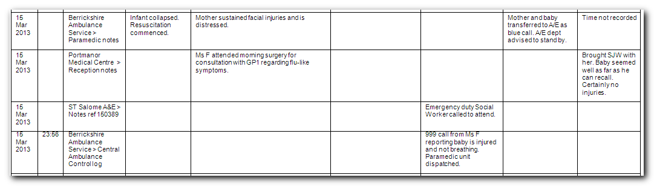
 |  |  | Press Tools > Sequencing > Add Column on the Chronolator toolbar: | A column headed Seq is added at the left of the table:  An Administrator can define a Sequencing column when setting up the document, or - as here - it can be added later.
Type the correct sequence numbers in the Seq column:
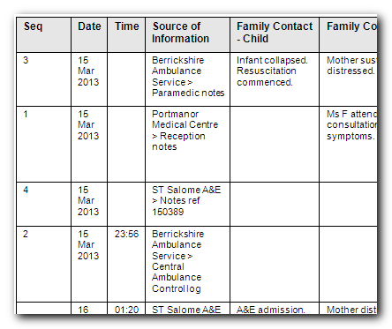
 |  |  | Press Sort Tables > Ascending on the Chronolator toolbar: | The events are put into the correct order:  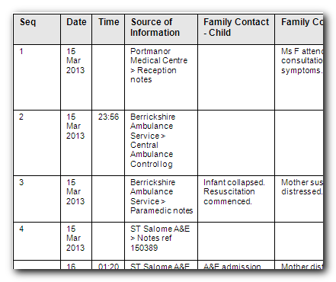
 |  |  | You do not always have to update sequence numbers in all the events, as Sort Tables recognises decimal numbers. For example, suppose that you now wanted to put event 4 before event 2 (this does not make sense in terms of the story, but we will do it here just to illustrate the feature).
 |  |  | Replace the ‘4’ in the event with a number between 1 and 2 - ‘1.5’ say: | 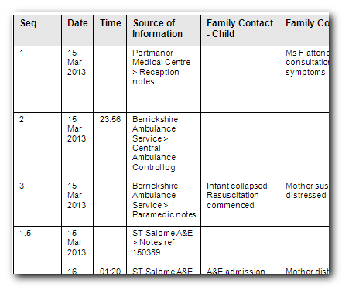
 |  |  | Press Sort Tables > Ascending: | The events are put into the requested order:  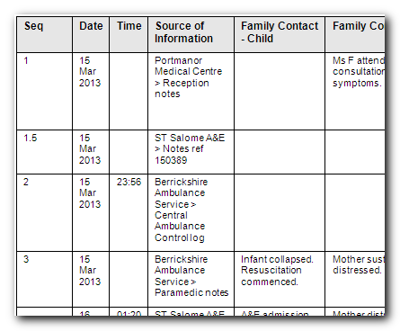  The decimal reference number is probably not what you want. Now that events are in the right order, you can update the numbers again . . .
 |  |  | Press Tools > Sequencing > Update - group by day:  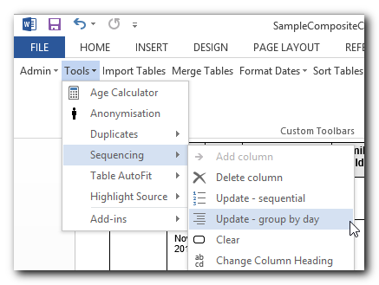 | The Seq column is updated with whole numbers:  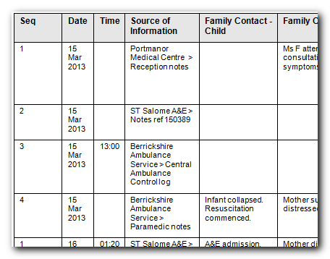
 |  |  | Close SampleCompositeChronologyHealth without saving changes.

In this exercise, you have seen that:
- you can use a Sequence column to force events into the right order when Chronolator has insufficient information about when they happened.
- you can add a Sequence column to a table which does not have one. This is the only change that Chronolator allows you to make to the column headings defined by the Case Review Administrator.

Exercise 8 - Highlighting events according to their agency or organisation
Chronolator can highlight events from different agencies in a number of ways.
Step | Action | What to expect and other comments
 | Read The Chronolator Toolbar on page 16, and About the Exercises on page 17 if you have not already done so.
 | Open SampleCompositeChronologyHealth. | This Composite Chronology contains events gathered from a number of health agencies:  - Berrick New Town Clinic  - Berrickshire Ambulance Service  - Portmanor Medical Centre  - ST Salome A&E  - St Salome Community Midwives  - St Salome Labour Ward  - St Salome Maternity Unit
 | Press Tools > Highlight Source > Define and Do on the Chronolator toolbar:  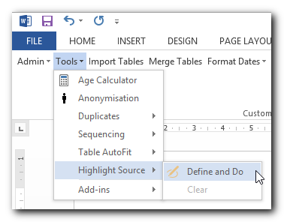 | The Highlight Source options selector is displayed:  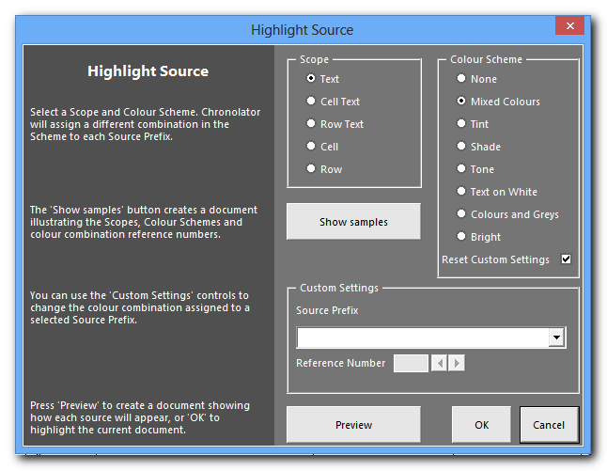  Chronolator has many options for choosing colour schemes and styles. We will just use the defaults for now.
 | Press OK:  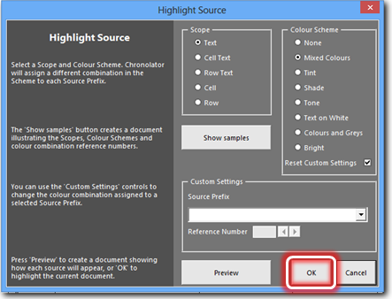 | The table is highlighted:  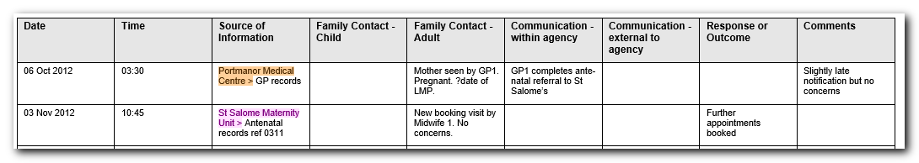
 | Press Tools > Highlight Source > Define and Do. | The Highlight Source options selector is displayed.
 | Press the Show samples button:  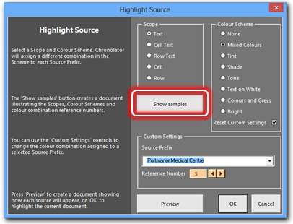 | A new document opens, explaining how the Scope and Scheme selectors work and containing swatches of the colours Chronolator can use to highlight the document:  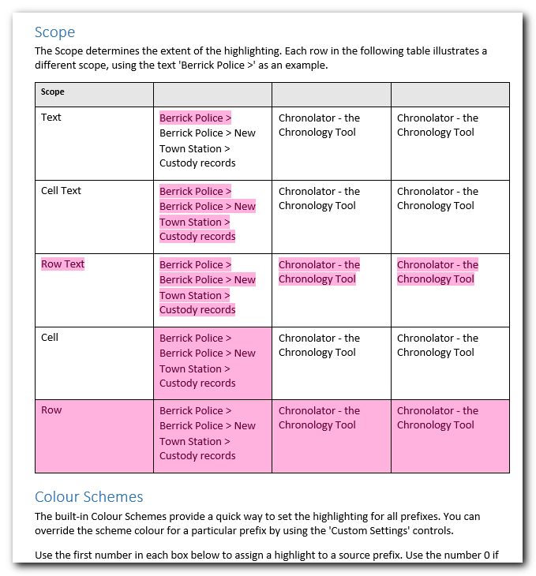
 | Close the new document. | You can leave it open if you want and switch back to SampleCompositeChronologyHealth.
 | Choose a Scope and Colour Scheme and press Preview:  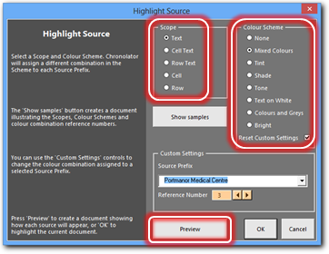 | A new document opens, illustrating how each source will be highlighted:  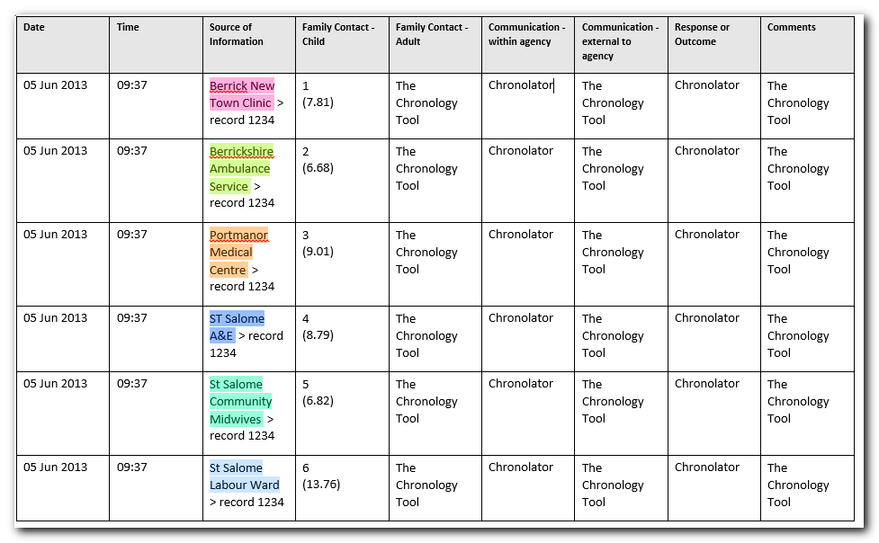
 | Close the new document. | You can leave it open if you want and switch back to SampleCompositeChronologyHealth.
Keeping the Scope and Colour Scheme you have chosen, click the drop-down arrow and select a Source Prefix:
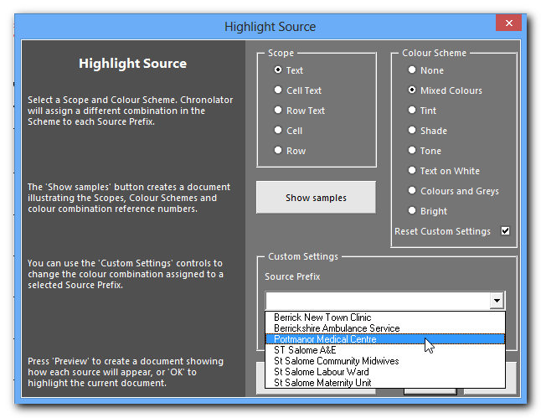
 | Experiment with the Custom Settings:  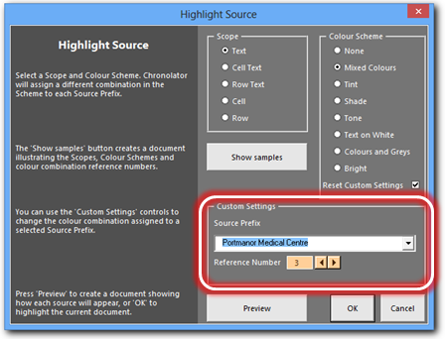 | The background of the number box and arrows is the colour to be assigned to the selected Source Prefix.  Use the arrows to choose a new colour, or type one in the box.  You will not be able to assign a colour if it is already in use, or if it is not a valid colour.
 | Use the Preview button again to preview your choices, or press OK to highlight the document.
 | Close SampleCompositeChronologyHealth without saving changes.

In this exercise, you have learned about the Highlight Source feature. In particular:
- you can set the extent of the highlighting by setting its Scope;
- Chronolator provides a number of different Colour Schemes;
- Scope and Colour Schemes are described in more detail when you press the Show Samples button;
- you can set the colour for individual Source Prefixes by using Custom Settings;
- you can Preview the highlighting before applying it to the document.

Exercise 9 - Anonymising and Personalising a chronology
Chronolator can anonymise a document according to the entries in its Abbreviations Glossary. It can be hard for a reviewer to build up a mental picture of the people involved in a case when they are only referred to by their initials, so Chronolator allows you to switch between anonymised and personalised views.
This exercise anonymises a document by replacing definitions in the Abbreviations Glossary with their abbreviations. Sometimes you might want to anonymise a document by replacing real names with fictitious ones. You can do that with a combination of the techniques below and those in Exercise 10 - Updating the Abbreviations Glossary on page 63.

Step | Action | What to expect and other comments
 | Read The Chronolator Toolbar on page 16, and About the Exercises on page 17 if you have not already done so.
 | Open SampleCompositeChronologyHealth. | This document has already been anonymised, as you can see from the first two rows which mention GP1 and Midwife 1:  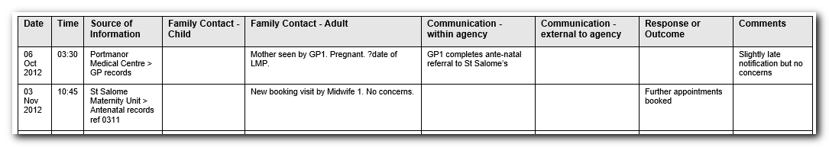
 | Press Tools > Anonymisation on the Chronolator toolbar:  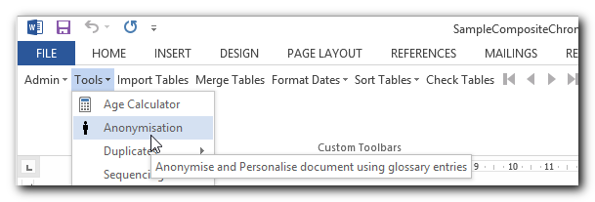 | Message 7010 is displayed:  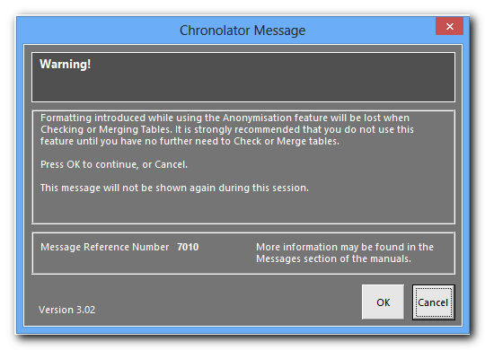  The Anonymisation feature can format abbreviations to make them stand out in the document. This formatting will be lost when certain other features are used.  It is recommended that you do not use Anonymisation until you have finished with those other features.  This message is only displayed once in a Word session.
 | Press OK. | The Anonymisation form is displayed showing the abbreviations in the document and their definitions:  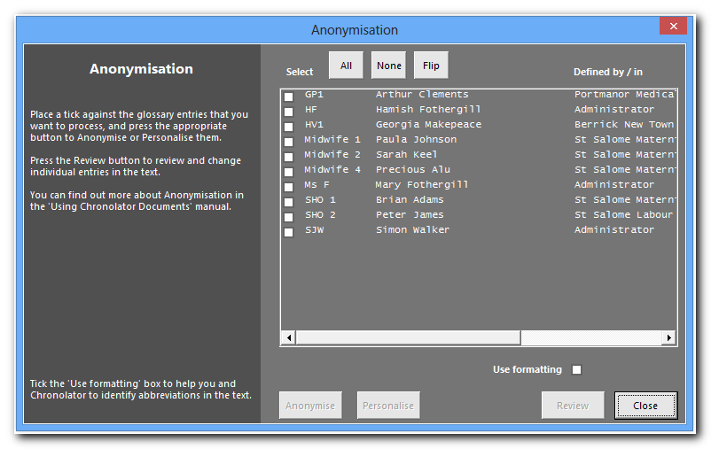  Note that GP1 is Arthur Clements and Midwife 1 is Paula Johnson.
 | Press the All button at the top of the form and then the Personalise one at the bottom. DO NOT tick the Use formatting box.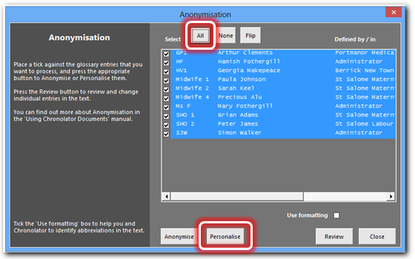 | The abbreviations in the document are replaced by their definitions:  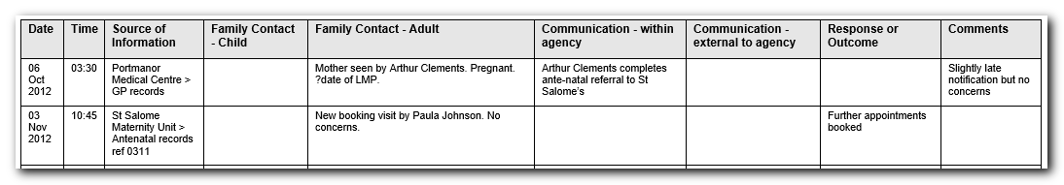  You can select particular entries to process by ticking the boxes next to them individually, but for this exercise we have done them all.  Be careful to follow the remaining steps exactly, as the Use formatting box has significant effects on Anonymisation and Personalisation.
 | Press Tools > Anonymisation. | The Anonymisation form is displayed.
 | Tick the Use formatting box and press the Anonymise button:  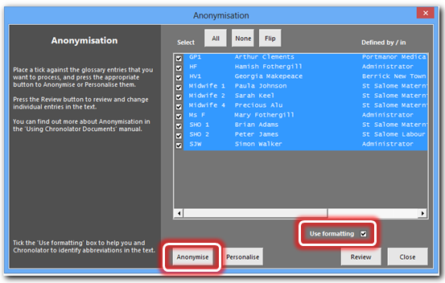 | The definitions in the document are replaced by their abbreviations, which are Bold, Italic, and Underlined:  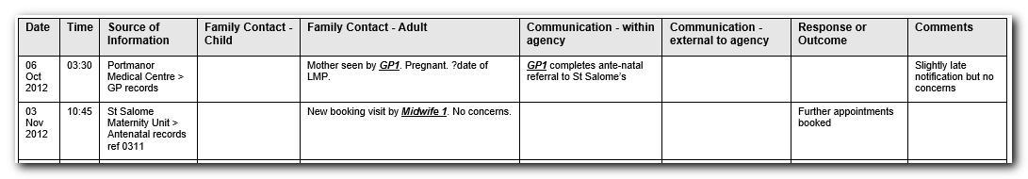  Formatting abbreviations like this makes them stand out in the document.  It can also be used to selectively process abbreviations, as we will see in the next few steps.
 | Press Tools > Anonymisation. | The Anonymisation form is displayed.
 | Don’t change anything.  Press the Personalise button. | The document is personalised.
 | Press Tools > Anonymisation. | The Anonymisation form is displayed.
 | Un-tick the Use formatting box.  Press the Anonymise button. | The document is anonymised without any formatting being applied.
 | Press Tools > Anonymisation. | The Anonymisation form is displayed.
 | Tick the Use formatting box  Press the Personalise button. | Message 7033 is displayed:  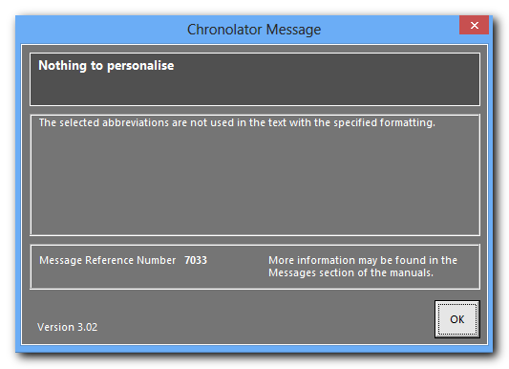  Because there are no abbreviations in the document which are Bold, Italic, and Underlined, no changes are made.
 | Press OK. | No changes have been made to the document.
 | Press Tools > Anonymisation. | The Anonymisation form is displayed.
Experiment with different combinations of the buttons and boxes on the form.
To see the results, close the form with the Close button in the bottom right hand corner. If you want to re-open it, press Tools > Anonymisation.
 | Close SampleCompositeChronologyHealth without saving changes.

This exercise has introduced you to the Anonymisation and Personalisation feature. Using the different buttons and boxes you can produce a document where some abbreviations are formatted and some are not, making some participate in Personalisation and some not.
Don’t forget that all this work could be lost next time you use the Check Tables button (and some others), so only do it if you have completed your work with them.
Remember also that the more complex the work you do, the harder it might be to recreate it if needed, and the harder it might be for someone else to understand the results. Keep it simple!

Exercise 10 - Updating the Abbreviations Glossary
Agencies can add their own entries to the Abbreviations Glossary. It is possible that two agencies might add similar entries (for example, AD/Alan Daniels and AD/Adam Donoghue). Chronolator always keeps track of where an abbreviation has been defined, but if you want to use the Anonymisation feature all abbreviations and definitions must be unique.
You can use the Admin > Abbreviations tool to change a user-defined Glossary entry. Chronolator updates the glossary and makes any required changes in the document.

Step | Action | What to expect and other comments
 | Read The Chronolator Toolbar on page 16, and About the Exercises on page 17 if you have not already done so.
 | Open SampleCompositeChronologyHealth.
 | Type Arthur Clements in the Family Contact - Child column in the first event so that it is as shown to the right. | 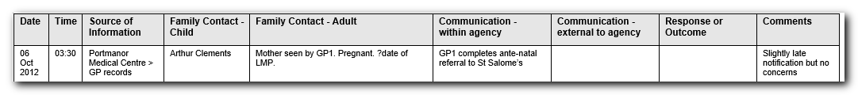
 | Press Admin > Abbreviations on the Chronolator toolbar:  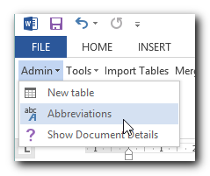 | A form is displayed showing the abbreviations in the document and their definitions:  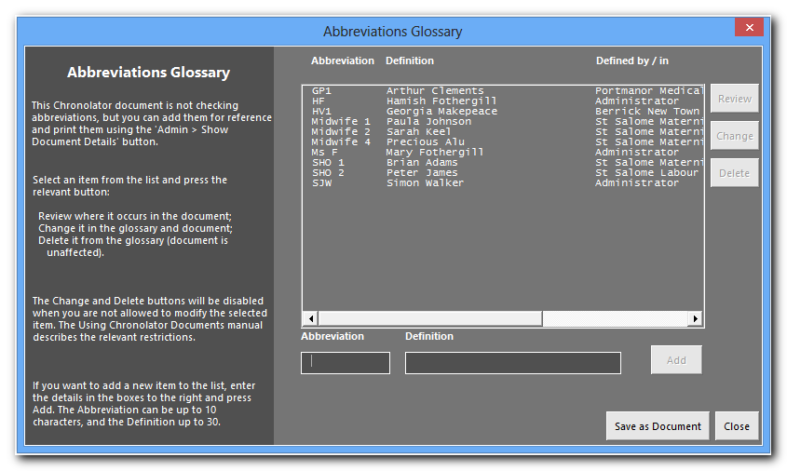  The Defined by / in column shows where an abbreviation has been defined.  You cannot change abbreviations defined by Administrator except in a Composite Chronology created by the Administrator.
 | Click GP1 Arthur Clements. | The Change button is enabled:  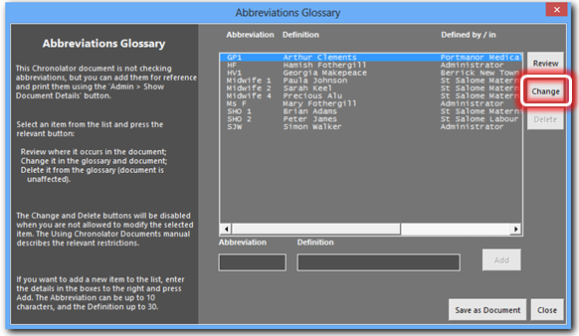
 | Press Change. | The current abbreviation and definition appear in the boxes near the bottom of the form, with a message inviting you to change them:  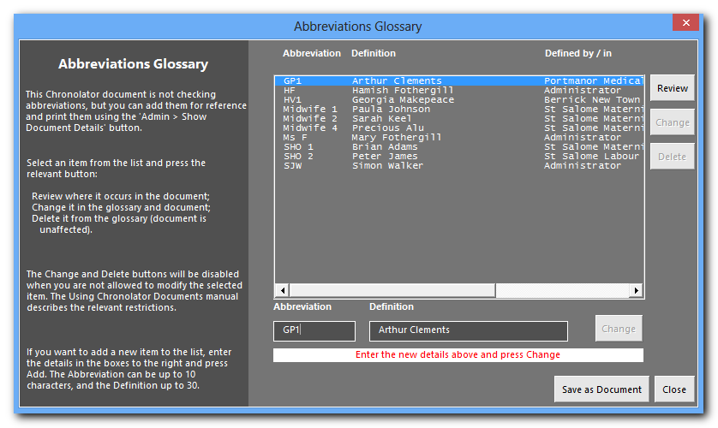
 | Type GP99 and Xaviera Yarrup and press the Change button next to them:  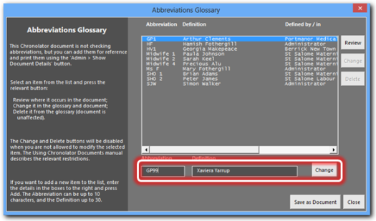 | The Glossary is updated:  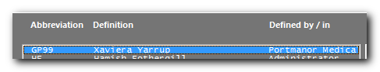  In this exercise you change both the Abbreviation and the Definition, but you can choose just to do either one.
 | Use the horizontal scroll bar at the bottom of the list to scroll it to the right. | 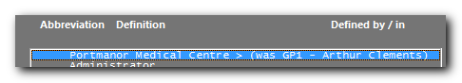  The original entry is still there, so you can always find it in the document in which it was first defined.  If you are using this feature to anonymise a document, remember not to publish it without first using the Publish > Exact Copy tool to produce a copy without any Chronolator code, and hence without the ability to reveal the abbreviations.
 | Press the Close button in the bottom right hand corner of the form. | Notice that GP1 and Arthur Clements have changed to GP99 and Xaviera Yarrup respectively:  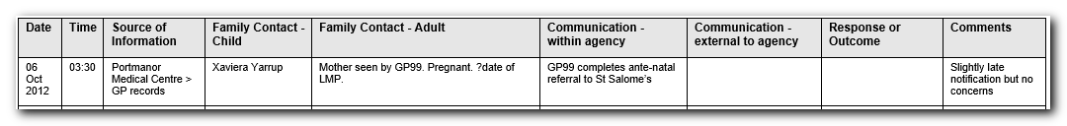
 | Close SampleCompositeChronologyHealth without saving changes.

In this exercise, you have learned:
- how to update the Abbreviations Glossary;
- that Chronolator updates the document text to match your changes.

In this exercise we changed the abbreviations in a Composite Chronology. However, it is worth checking before you import a document whether it contains any abbreviations that are the same as those in the Composite Chronology. If so, consider changing them before the import. The end result in the Composite Chronology will be the same, but you might think that the additional consistency between it and the imported document is worthwhile.

Exercise 11 - Navigating a document and extracting events using the Abbreviations Glossary on page 67 illustrates how you can browse a document using the Abbreviations Glossary and produce a summary document containing only the events pertaining to selected glossary entries.

Exercise 11 - Navigating a document and extracting events using the Abbreviations Glossary
When your chronology contains an Abbreviations Glossary, you can quickly navigate between individual glossary entries in the document. You can also produce extracts containing just the events pertaining to those entries.
If you are interested in just one abbreviation, you can use the Admin > Abbreviations tool. In the following exercise, we use Tools > Anonymisation as it lets us process more than one abbreviation at a time.
Step | Action | What to expect and other comments
 | Read The Chronolator Toolbar on page 16, and About the Exercises on page 17 if you have not already done so.
 | Open SampleCompositeChronologyHealth.
 | Press Tools > Anonymisation on the Chronolator toolbar: | Message 7010 is displayed:  The Anonymisation feature can format abbreviations to make them stand out in the document. This formatting will be lost when certain other features are used.  It is recommended that you do not use Anonymisation until you have finished with those other features.  This message is only displayed once in a Word session.
 | Press OK. | The Anonymisation form is displayed showing the abbreviations in the document and their definitions:
 | Tick GP1 and Midwife1 and then press the Review button:  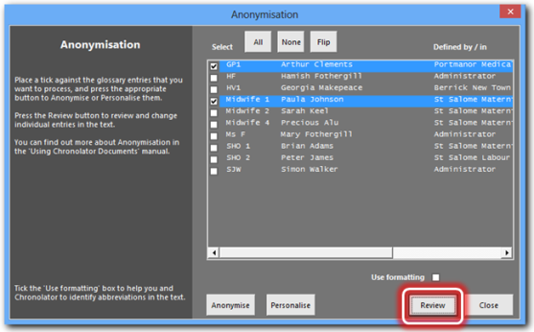 | The Change Abbreviations form is displayed, and occurrences of GP1 and Midwife 1 are highlighted in the document:  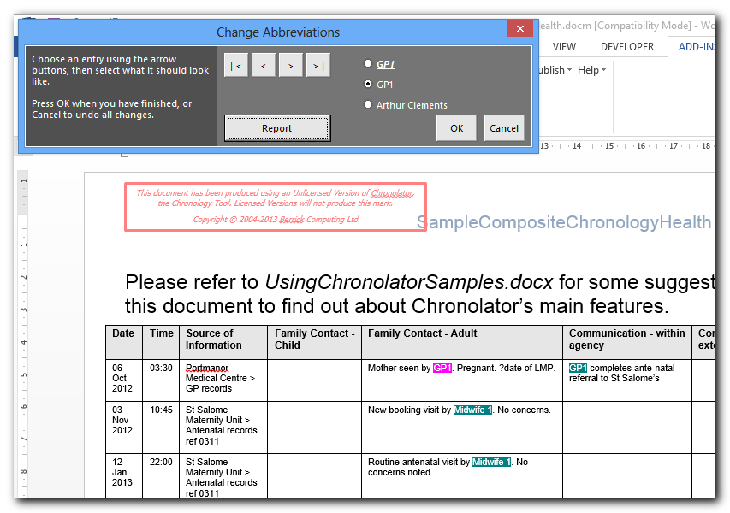  The active occurrence (the one where the cursor is placed) is highlighted like this, and the others like this.
 | Use the buttons in the form to scroll among the occurrences of GP1 and Midwife 1:  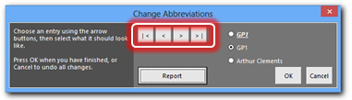 | The active occurrence is highlighted like this.
 | Experiment with the radio buttons: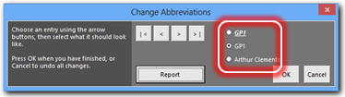 | The text of the active occurrence changes to whatever you select.  You might want to do this to selectively anonymise or personalise a particular occurrence.
 | Press OK:  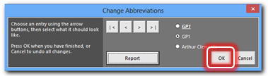 | The form closes.  Highlights are removed.  Any changes you have made are kept.  If you did not want to keep the changes, you would press Cancel.
 | You have seen how to navigate among the glossary entries. In the next part of this exercise, you will see how to produce a new document containing just the events pertaining to those entries.
 | Press Tools > Anonymisation: | The Anonymisation form opens with your previous selections.
 | Press the Review button: | The Change Abbreviations form is displayed, and occurrences of GP1 and Midwife 1 are highlighted in the document as before, as are their respective names if you changed any of the entries to them earlier.
 | Press the Report button:  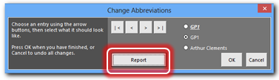 | A new document opens, containing only those events which involve GP1 and Midwife 1 and their respective names:  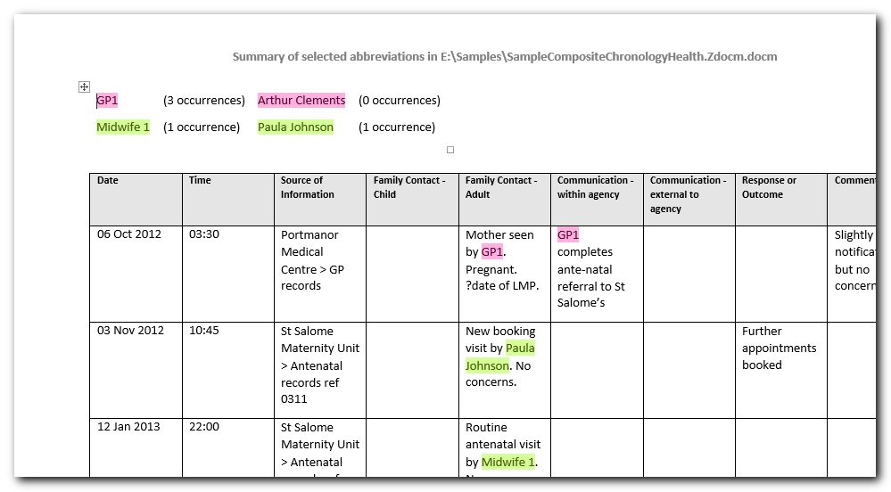
 | Close the new document and SampleCompositeChronologyHealth without saving changes.

In this exercise, you have learned:
- how you can use the entries in the Abbreviations Glossary to navigate the document;
- how to produce a report about selected entries.

Exercise 10 - Updating the Abbreviations Glossary on page 63 illustrates how you can change entries in the Abbreviations Glossary and any associated text in the document.

Exercise 12 - Making a narrative version of the chronology table
Although tables are a good way to put a chronology together, they can be unwieldy to read, particularly when a single event has a lot of text in one column that spans several pages.
Chronolator can convert a chronology table to a number of narrative formats, some of which include the time that has elapsed since the start of the chronology.
Step | Action | What to expect
 | Read The Chronolator Toolbar on page 16, and About the Exercises on page 17 if you have not already done so.
 | Open SampleCompositeChronologyHealth.
 | Press Publish > Custom on the Chronolator toolbar:  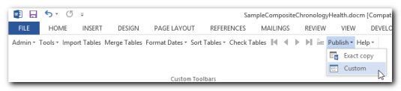 | The Published Document Customisation form opens:  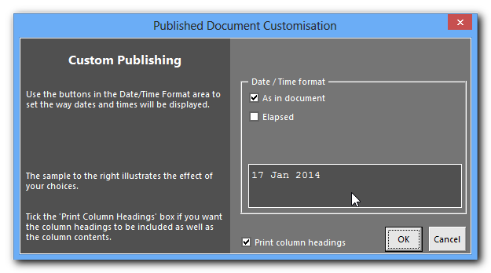  You can use this form to change how the table headings are displayed.  We will just use the defaults for now.
 | Press OK. | A new document is produced containing a narrative version of the chronology table. The standard Word Save As dialog is displayed.
 | Save the document in a convenient place.
 | Look at the way the first event appears: | In the original chronology table:  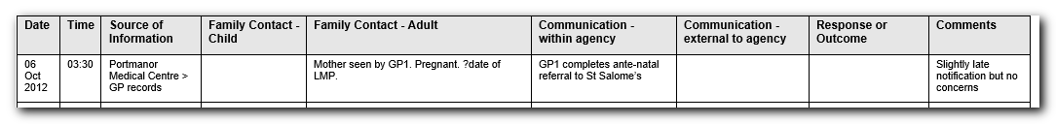  In the narrative:  - The main heading shows the Date and Time of the event as written in the table;  - The next one is the Source of Information;  - The following ones include only those table columns in which there was information.  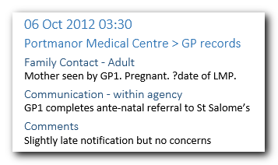  In the next few steps we shall see how to customise these headings.
 | Close the narrative document.
 | Switch back to SampleCompositeChronologyHealth and press Publish > Custom.  Un-tick the Print Column Headings box:  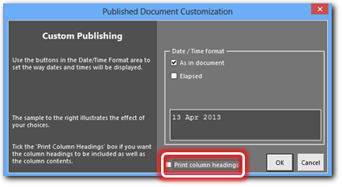  Press OK. | A new document is produced containing a narrative version of the chronology table. The standard Word Save As dialog is displayed.
 | Save the document in a convenient place. | Overwrite the earlier narrative document if you want to.
 | Look at the way the first event appears in the narrative: | 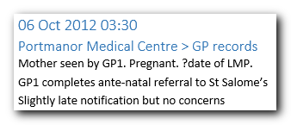  The Date and Time and Source of Information headings remain, but the other ones are omitted. This results in a shorter document.
 | Close the narrative document.
 | Switch back to SampleCompositeChronologyHealth and press Publish > Custom.  Set the form as follows:  - Tick As in document;  - Tick Elapsed;  - Select Partial;  - Tick Print Column Headings.  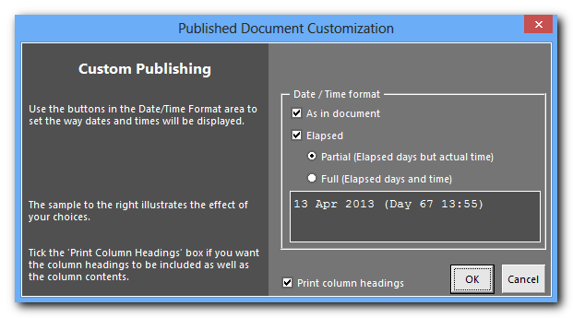  Press OK. | A new document is produced containing a narrative version of the chronology table. The standard Word Save As dialog is displayed.
 | Save the document in a convenient place. | Overwrite the earlier narrative document if you want to.
 | Look at the way the first two events appear: | In the original chronology table:  In the narrative:  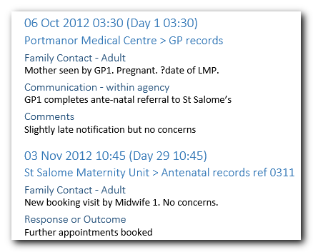  Ticking Elapsed has made the Date and Time heading of each event include information about how long it has been since the start of the chronology.  There are two formats for the Elapsed option. Partial (used here) displays how many days it has been since the first event but shows the time it happened.
 | Close the narrative document.
 | Switch back to SampleCompositeChronologyHealth and press Publish > Custom.  Set the form as follows:  - Tick As in document;  - Tick Elapsed;  - Select Full;  - Tick Print Column Headings. | Notice that as you choose different options, their effect is illustrated in the box underneath them:  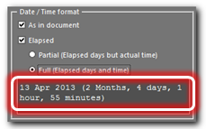
 | Press OK. | A new document is produced containing a narrative version of the chronology table. The standard Word Save As dialog is displayed.
 | Save the document in a convenient place. | Overwrite the earlier narrative document if you want to.
 | Look at the way the first two events appear in the narrative: | 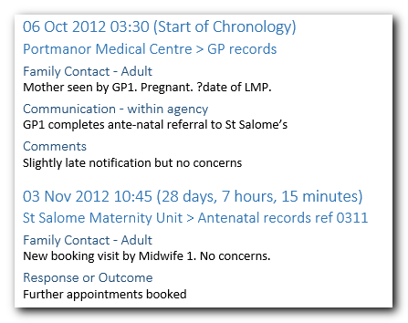  The Elapsed Full option displays exactly how long it has been since the first event instead of the time it happened.
 | Close SampleCompositeChronologyHealth without saving changes.

In this exercise, you have seen that:
- you can translate a tabular chronology into a variety of narrative formats, which can be easier to read and often take fewer pages;
- some formats include information about the interval between the start of the chronology and each event;
- the narrative is produced in a separate document, leaving your original chronology unchanged.

Conclusion
The exercises above have illustrated the major features of Chronolator. Working through them should make you confident in using it for your own reviews. Detailed information about the tools available on the Chronolator toolbar in a chronology document can be found in Using Chronolator Documents, which also includes some information about working with Word tables in general for those who are unfamiliar with them.
The sample tables in the exercises all use the same columns and headings. Please note that Chronolator allows the Case Review Administrator to decide what columns are used in any particular review. How this is done is described in Setting Up Chronolator Documents.
Visit the Chronolator web site www.chronolator.co.uk to see:
- video demonstrations;
- FAQs about:
  - installing Chronolator, and what are its pre-requisites (pretty much just Microsoft Word);
  - general usage;
  - known problems;
- information about how to get a licence;
- information about how to report problems.
The web site also has links from which you can download:
- a complete working version of Chronolator;
- the Sample documents used in the above exercises;
- a Quick Demonstration illustrating the speed with which Chronolator can merge and format chronology tables;
- the Chronolator documentation, including that for historical versions.

An Internal Chronology contains events from a single organisation or department
A Composite Chronology contains events from more than one organisation or department
Firstly, anonymise the document as described in this exercise; then change the definitions for an abbreviation in the Glossary; finally, personalise the document as described here.

